**MULTIMODAL AND MULTILINGUAL BASED CLASSIFICATION OF SOCIAL MEDIA DATA**

**PROJECT SYNOPSIS**

OF MINOR PROJECT

# **BACHELOR OF TECHNOLOGY**

COMPUTER SCIENCE AND ENGINEERING

SUBMITTED BY

# AAYUSH KALIA ABHIJOT SINGH CHAITANYA ARORA

2215003 2215004 2215027

2203414

2203391

2203390

UNDER THE GUIDANCE OF

ER. MEETALI



**GURU NANAK DEV ENGINEERING COLLEGE,**

**LUDHIANA**

**TABLE OF CONTENT**

|  |  |
| --- | --- |
| **CONTENT** | **PAGES** |
| **1. INTRODUCTION** | **3** |
| **2. RATIONALE** | **4-5** |
| **3. OBJECTIVES** | **6** |
| **4. LITERATURE REVIEW** | **7-8** |
| **5. FESIBILITY STUDY** | **9-11** |
| **6. PLANNING OF WORK** | **12** |
| **7. FACILITIES REQUIRED** | **13** |
| **8. EXPECTED OUTCOMES** | **14** |
| **8. REFERENCES** | **15** |

## INTRODUCTION

**MULTIMODAL AND MULTILINGUAL BASED CLASSIFICATION OF SOCIAL MEDIA DATA** is an innovative ML-driven content filtration system designed to tackle the increasing prevalence of harmful content on social media platforms. It addresses critical issues such as hate speech, offensive language that can harm online communities and individuals. It ensures effective, scalable, and classification of digital spaces.

Key technologies and features include:

**1.1 Sentiment Analysis:**

* Categorizes content into emotions like happiness, sadness, anger, and excitement, love.
* Enables proactive identification of harmful posts that could incite negative interactions.

**1.2 Machine Learning Models:**

* Utilizes state-of-the-art algorithms such as BERT, trained on diverse labeled datasets.
* Continuously improves through retraining on new data and evolving trends in social media content.

**1.3 Technological Framework:**

* Run the entire system locally using a Python environment, requiring minimal setup and infrastructure.
* PyTorch and Natural Language Toolkit (NLTK) for implementing the content moderation logic and machine learning models.

1. **RATIONALE**

The increasing prevalence of harmful content on social media calls for a scalable, efficient, and ethical solution. **Multimodal and Multilingual based classification of Social Media Data** is designed to address this need with the following major objectives:

**2.1 Protecting Users:**

* Harmful content such as hate speech and offensive language negatively impacts user experiences and mental health.
* This project ensures safer online spaces by detecting and filtering such content, promoting respectful interactions and reducing the risk of harassment and bullying.

**2.2 Reducing Manual Effort:**

* Moderating massive volumes of user-generated content manually is labor-intensive, time-consuming, and expensive.
* **Multimodal and Multilingual based classification of Social Media Data** automates tasks like content detection and flagging, reducing reliance on humans and enabling quicker responses to harmful content.

**2.3 Improved Engagement:**

* Users are more likely to participate and engage actively when they feel safe from harmful content.
* By fostering trust in the platform’s moderation capabilities, **Multimodal and Multilingual based classification of Social Media Data** encourages positive interactions and supports the growth of a healthy online community.

**2.4 Supporting Ethical Responsibility:**

* Governments and regulators increasingly require platforms to address harmful content proactively.
* **Multimodal and Multilingual based classification of Social Media Data** helps platforms meet these demands while upholding freedom of expression, aligning with ethical standards and legal obligations.

Top of Form

Bottom of Form

### 3. OBJECTIVES

* To identify and extract patterns from social media content based on sentiments.
* To Classify and categorize the data using ML techniques.
* Compare and contrast various ML methods for sentiment analysis based certain parameters.

**4. LITERATURE REVIEW**

Shirzad et al. explore the growing trend of social media users expressing emotions and sentiments through visual media like GIFs, videos, and images. They developed a multimodal sentiment analysis tool in Python to analyze tweets, taking into account not just the text, but also the accompanying GIFs and images, to improve the accuracy of sentiment scores. For image sentiment analysis, they use a fine-tuned Convolutional Neural Network (CNN), while for text, they rely on VADER. For GIFs, they combine image sentiment analysis with facial expression recognition, processing each frame to assess the sentiment. Their approach shows that incorporating both textual and visual features leads to better performance compared to models that rely only on text or images. The final sentiment score for each tweet is calculated by aggregating the sentiment outputs from the text, image, and GIF modules.

Jing You et al. focus on sentiment analysis in product reviews, emphasizing the importance of multimodal data—text, images, and audio—in understanding consumer sentiments. They introduce a novel method that utilizes pre-trained models for feature extraction from both images and text, enhancing sentiment analysis through cross-attention mechanisms. Experiments on a multimodal dataset demonstrate that their method outperforms existing techniques, showcasing the effectiveness of integrating multiple data types.

Seng et al. address the complexities of emotion and sentiment modeling in unstructured big data. They provide an overview of current methodologies and propose a new architecture comprising modules for data collection, aggregation, feature extraction, fusion, and application. Their innovative feature extraction techniques, Div-ConPCA and Div-ConLDA, enhance the modeling process for multimodal data. The proposed architecture effectively tackles challenges presented by unstructured data in today's digital landscape.

Fortin et al. examine multimodal sentiment analysis, particularly scenarios where not all modalities are available during testing. They present a multitask framework that integrates available modalities while maintaining performance when some are missing. Their model includes separate classifiers for text and images, with an additional fusion component. This approach addresses the issue of missing modalities and enhances generalization through regularization techniques.

Miah et al. explore foreign language sentiment analysis, proposing an ensemble model that translates non-English texts into English before performing sentiment analysis. They utilize neural machine translation models to convert Arabic, Chinese, French, and Italian texts into English, analyzing sentiments using various pre-trained models. Results indicate that this translation-based approach achieves over 86% accuracy in sentiment classification, demonstrating its potential for effective multilingual sentiment analysis.

**5. FEASIBILITY STUDY**

The feasibility study for the MULTIMODAL AND MULTILINGUAL BASED CLASSIFICATION OF SOCIAL MEDIA DATA is a critical step in understanding the viability, need, and significance of the project. Below outlines the various aspects of feasibility:

**Assessment of Viability:**

**5.1 Technical Feasibility:**

* Use Python with libraries like TensorFlow, PyTorch, and NLTK for model implementation.
* Leverage pre-trained models like BERT or OpenAI's GPT, which are optimized for NLP tasks.

**5.2** **Economic Feasibility:**

* Leverage open-source tools to minimize costs.
* Use freemium services for initial deployment and expand based on user adoption.

**5.3 Operational Feasibility:**

* We can train and execute the model directly through the terminal, reducing development complexity.
* Highly portable and easy to deploy on local machines or cloud platforms.

**5.4 Schedule Feasibility:**

* Follow Agile methodology like Scrum for effective development cycles.
* Allocate time for iterative testing and optimization.

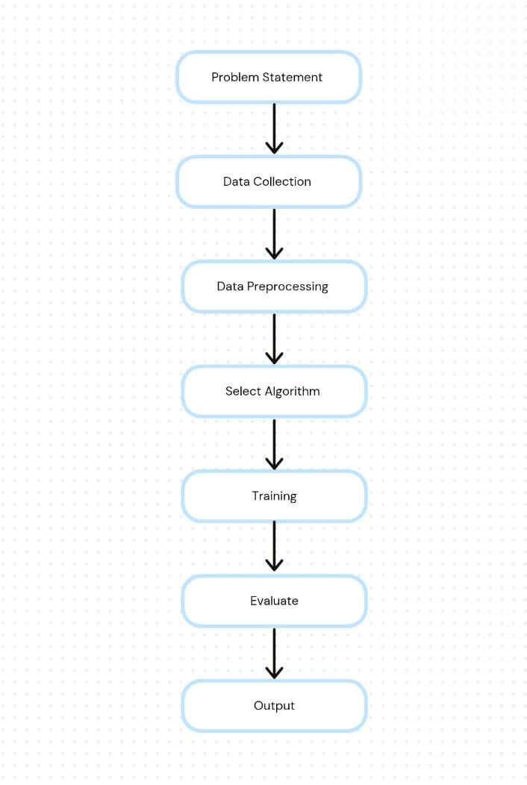

Fig 1: Machine Learning Model

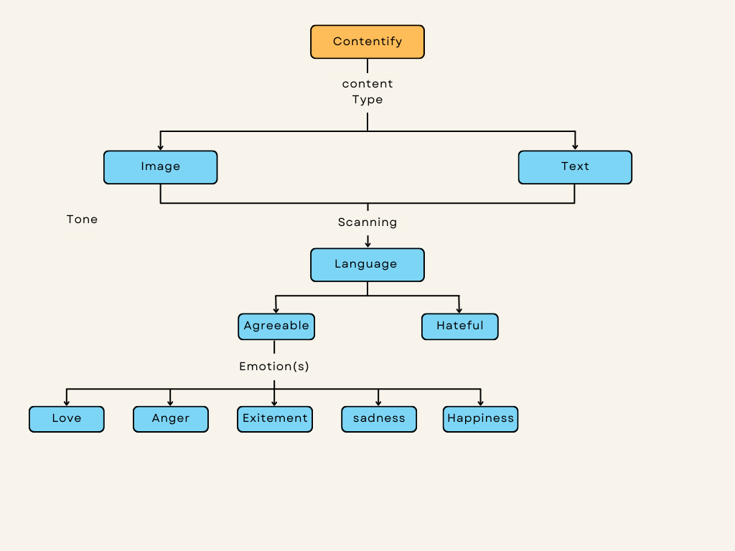**6. PLANNING OF WORK**

Fig 2: Flow Diagram of Multimodal and Multilingual based classification of Social Media Data

**6.1 Requirements Gathering:**

* Read and review research papers to understand key needs and challenges. Focus on defining essential features like emotion categorization, etc.
* Document the requirements, including the types of harmful content to be detected (hate speech, misinformation, etc.).
  1. **Design:**
* Design a structured command-line interface (CLI) and focus on building modular components for sentiment analysis, harmful content detection.

**6.3 Development:**

* Train and fine-tune sentiment analysis and content detection models using libraries like PyTorch.
* Use pre-trained models such as BERT and adapt them for detecting harmful content and categorizing emotions.

**6.4 Testing:**

* Conduct unit, system, and simulation testing to ensure each module works as intended.
  1. **Deployment:**
* Set up the system to run on local machines with minimal dependencies, ensuring portability and ease of use.
* Use performance metrics to fine-tune models and optimize the system.
  1. **Maintenance and Support:**
* Offer support services to address any emerging issues and fix bugs reported by users.

**7. FACILITIES REQUIRED**

To undertake the development of the MULTIMODAL AND MULTILINGUAL BASED CLASSIFICATION OF SOCIAL MEDIA DATA, the following facilities are required:

**7.1 Hardware:**

* Computers equipped with ample processing power and memory to support ML activities.

**7.2 Software:**

* A proficient code editor like Visual Studio Code or Python IDE for efficient development.
* Libraries such as PyTorch, Word2Vec, and NLTK for implementing machine learning models and natural language processing tasks.

**7.3 Human Resources:**

* A team skilled in Python, machine learning, and NLP techniques to build, train, and test models.
* Technical writers to meticulously document the app's functionalities and features.

**7.4 Infrastructure:**

* High-speed internet for downloading datasets, pre-trained models, and required libraries.

**7.5 Legal and Financial Requirements:**

* Ensure that all datasets used for training are open-source or properly licensed.
* Adherence to data privacy laws and regulations to ensure user information protection.

**8. EXPECTED OUTCOMES**

The successful development and implementation of **Multimodal and Multilingual based classification of Social Media Data** are anticipated to yield several significant outcomes, addressing critical challenges in content moderation and positively impacting social media platforms and their users. The expected outcomes include:

**8.1 Accurate Detection of Harmful Content:**

* Reliable identification and categorization of harmful content such as hate speech, and offensive language.

**8.2 Improved Sentiment Analysis Capabilities:**

* Effective classification of content into emotions like happiness, sadness, anger, and excitement, love.

**8.3 Simplified and Cost-Effective Moderation:**

* By eliminating the need for complex infrastructure such as databases and front-end/back-end systems, the system remains lightweight and easy to deploy.

**8.4 Portable Solution:**

* The terminal-based implementation allows the system to be easily run on local machines or cloud platforms.
  1. **Enhanced User Trust and Safety:**
* Promotes safer online spaces by minimizing exposure to harmful content.

**REFERENCES**

**[1] Python –** Python documentation [Our Documentation | Python.org](https://www.python.org/doc/)

**[2] PyTorch** - PyTorch documentation [PyTorch documentation — PyTorch 2.5 documentation](https://pytorch.org/docs/stable/index.html)

**[3] NLTK -** NLTK, is a suite of libraries and programs for symbolic and statistical natural language processing (NLP) for English. [NLTK :: Natural Language Toolkit](https://www.nltk.org/)

**[4] Canva** - Design Anything. Publish Anywhere <https://www.canva.com/>

**[5] Word2Vec -** Word2vec is a technique in natural language processing for obtaining vector representations of words. [models.word2vec – Word2vec embeddings — gensim](https://radimrehurek.com/gensim/models/word2vec.html)

**[6]** Multi-modal Hate Speech Detection using Machine Learning: Fariha Tahosin Boishakhi,

Ponkoj Chandra Shill, Md. Golam Rabiul Alam

**[7]** Machine Learning based Automatic Hate Speech Recognition System: P. William, Ritik Gade, Rupesh Chaudhari, A.B. Pawar

**[8]** Exploring Machine Learning Methods for Hate Speech Detection on Social Media:Deepti Negi, Mahesh Manchanda, Aditi Kala, Aditya Harbola

**[9]** Detection of hate speech in Social media memes: Ajay Nayak, Anupam Agrawal

**[10]** Detecting Hate Speech on Social Media with Respect to Adolescent Vulnerability: Anna Chiu, Kanika Sood, Ariadne Rincon, Davina Doran

**[11]** Emotion Recognition Using Multimodal Approach: Samiksha Saini, Rohan Rao, Vinit Vaichole, Anand Rane. Deepa Abin

**[12]** Multimodal Social Media Sentiment Analysis: Pratyush Muthukumar, Mubarak Ali Seyed Ibrahim